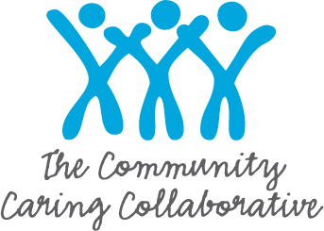
Early Childhood Consultation and Outreach (ECCO)
For Internal Use Only
ECCO ID #:___________
Child Referral Form
I am referring a: □ Child □ Classroom/Center/School (see other side) |  | Date:
Name of child/center being referred: |  | DOB:
Parent/Caregiver: | Phone: | Ok to leave msg? Yes No
Person Making Referral: | Agency: | Phone:
Reason for Referral

Child’s/Family’s Strengths:

Others in the Home (Please include Name, Age and Relationship):

Interactions with parents, family/caregivers/peers:

Please describe any changes (positive or negative) that have taken place in the environment and their effects:

Other information that may be helpful (if the child has a diagnosis, please include it here):

Please send referral form to Julie Redding, Community Caring Collaborative
Julie Redding, LCPC jredding@cccmaine.org
225 Shattuck Road, Calais ME 04619
Cell: 207.214.8434 Fax: 207.952.9182

Early Childhood Consultation and Outreach (ECCO)
Classroom – Center -- School
For Internal Use Only
ECCO ID #:___________
Referral Form
I am referring a: □ Classroom □ Center □ School | Date:
Name of Center/School being referred: | Phone:
Center/Classroom teacher name: | Grade:
Person Making Referral: | Role:
Number of Students in Classroom:
Number of times students have been removed from classroom due to disruptive behavior:
Number of times that student(s) have been suspended or removed from classroom for more than one day:
Number of students referred to Special Ed, Child Find, CDS, Day Treatment:
Number of students attending school under a modified day?
What type of supports are you looking for?

Please send referral form to Julie Redding, Community Caring Collaborative
Julie Redding, LCPC jredding@cccmaine.org
225 Shattuck Road, Calais ME 04619
Cell: 207.214.8434 Fax: 207.952.9182

