Needs for Shelter
03/06/2024
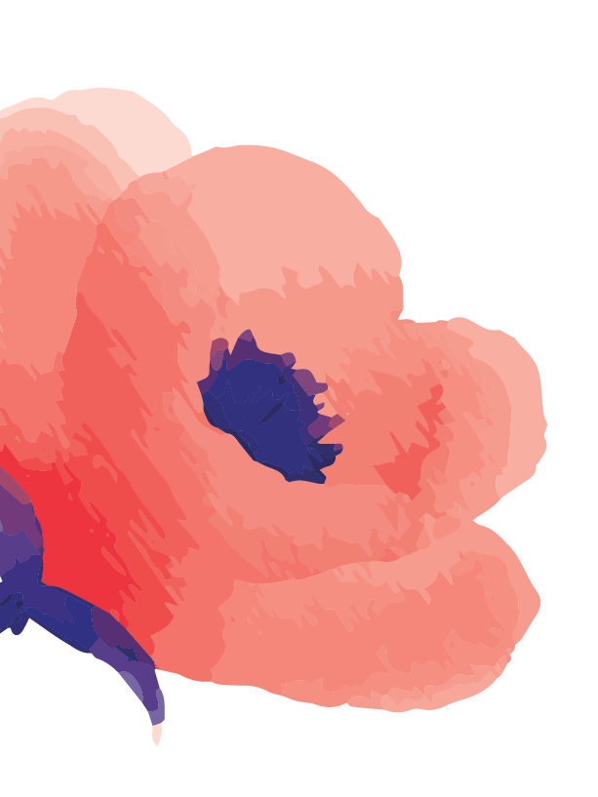 |  |  |  | - Shampoo/Conditioner  - Deodorant  - Body wash  - Lotion  - Hairbrushes/combs  - Q-tips  - Nail Clippers  - Washcloths  - Towels  - If you have any other items that you would like to donate, please call, or email the address on the right.  - Please do not leave items at the  office door.  THANK YOU
23 Broadway
Machias Me 04654

207-460-7265
1-800-315-5579

 | bmason@nextstepdvproject.org
 | www.nextstepdvproject.org

